Shock Test Results:-  
  
These tests are done for 3 kind of defects in Cam 3 images:-

1. Short Mitre - defective or non_defective ( 2 classes)
2. Long_Mitre - defective or non_defective ( 2 classes)
3. Label - defective, non_defective and laser print blank ( 3 classes)

All files of shock test are available here in zip format

<https://drive.google.com/file/d/1Xjc3NzlB_ZX7tefj_4rrlK--xu0ZKR2M/view?usp=sharing>

1. SHORT MITRE

Defective Predicted were 98 items

Correctly defective predicted 83 Double packet (smiley) 7 False Detection 8

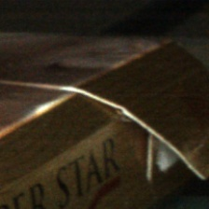 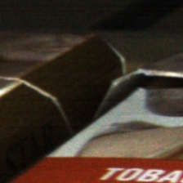 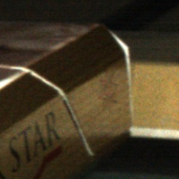

Non_defective predicted 629 (all correct)

(Afterwards new model has been trained which makes false detection rate to app. 0.05%)

B) LONG_MITRE

Defective Predicted (151 items)

Correct long seam open 142 Camera errors then too correct 7 Camera error wrong prediction 2

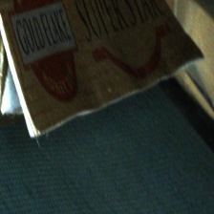 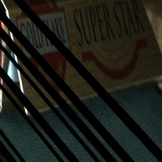 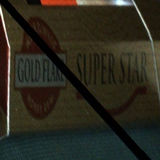

Non_defective predicted 58

Correctly predicted 30 Very less opening from bottom end 10

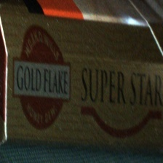 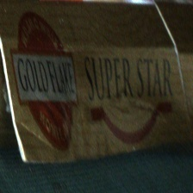

Less opening from top end 15 Fully open incorrectly predicted 2  
 

c) LABEL SHOCK TEST

Label print missing predicted 77

Correct predicted 75 One fully defective packet detected False detection due to camera error 1

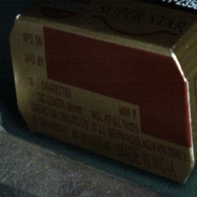 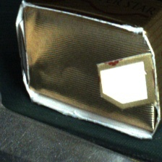 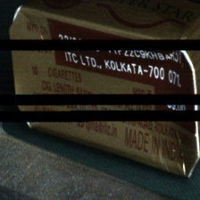

Defective predicted 99

Correct defective 97 Camera error 2

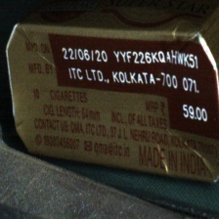 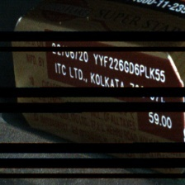

Undefective predicted 120

Correct predicted 115 reverse packet 1 defective packet 4

